Lugg adventure 7-11 August 2022: journey by Sophie Marsh
from the River Lugg’s source on Pool Hill above Llangunnlo to its confluence with the Wye just beyond Mordiford - around 100km

The red pins mark the stopping points.
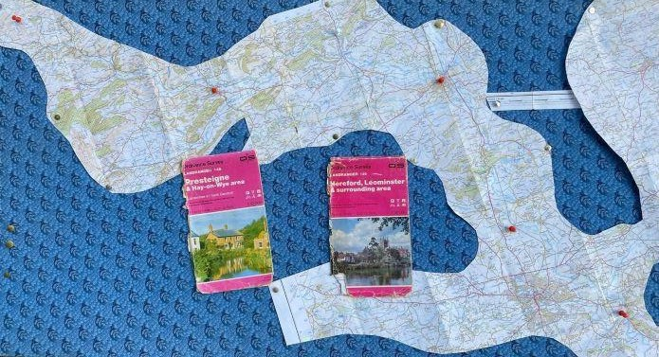

Sunday 7/8: Day 1: Source to Presteigne, foot and bike, 17ish miles

A lovely first day of my #Luggadventure, from the beautiful hills and heather at the source, through farm valleys all the way to Presteigne.
The river remained relatively clear and locals were enjoying its swimming holes in the hot weather
...where there was water. In some places the river was nowhere to be seen (either dried up or underground)!
The Mayor of Leominster, my aunt, Trish Marsh, provided great company for much of the walk.
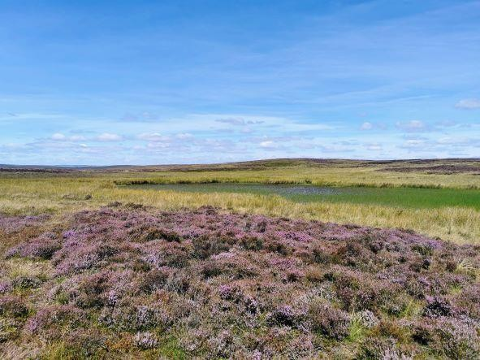
Wonderful heather - but little water at the source

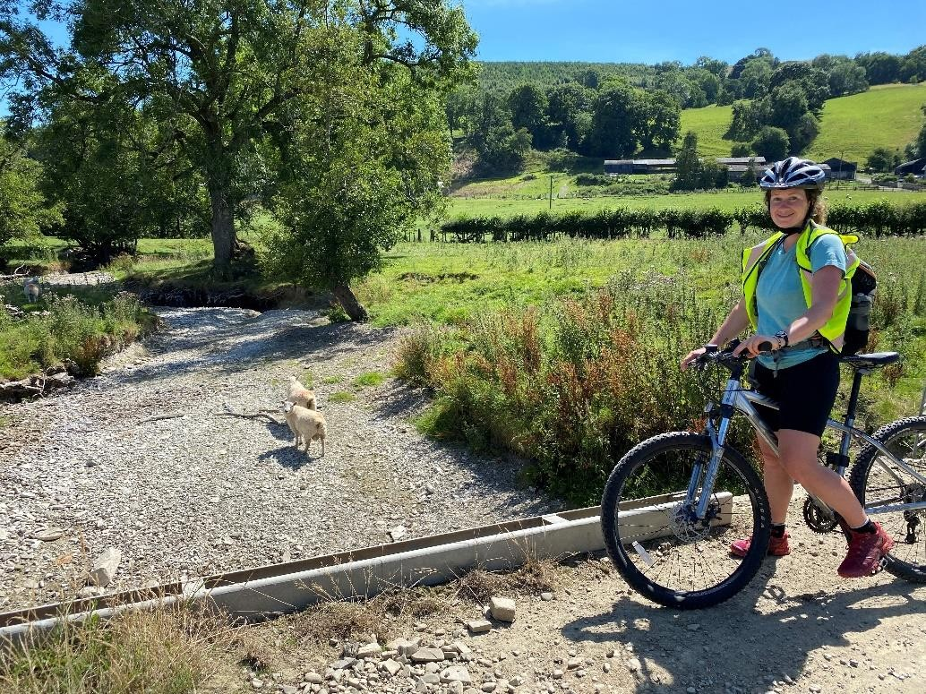
A dry riverbed several miles downstream of the source: locals said they hadn’t seen it this dry before.

Thanks to:-
- Martin Redfearn, secretary of CPRW, who led us up to the source to start the walk.
- A friend for hospitality in Presteigne overnight and networking.

Monday 8/8: Day 2: Presteigne to Aymestrey, on foot, 10ish miles.

Day 2 of my #Luggadventure started with meeting a group of citizen scientists and concerned locals at the Wales-England border.
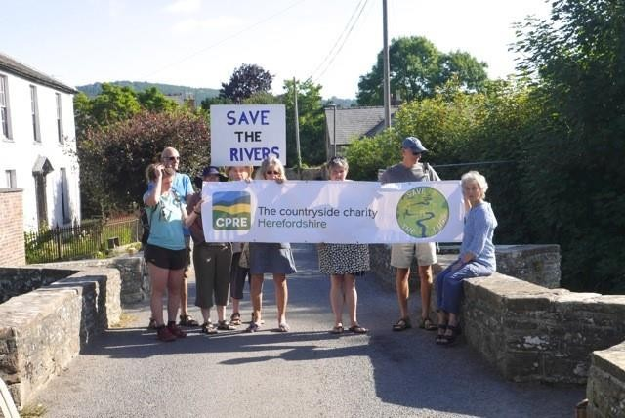
Thanks to:-
- the Mayor of Presteigne, Cllr Debbie Edwards, and others for their concern for the River Lugg
(Afon Llugwy in Wales) and their send off at the Old Bridge, the border.

Then we set off through fields of sheep, cows, barley and potatoes, with the hot sun making walking very tiring!

The woods near Kinsham provided much needed shade and a lovely lunch stop, with two young deer and delicious wild blackberries! ...Though stinging nettles and shorts weren't an ideal combination.
The river seems a bit murkier than yesterday and definitely low in places, but generally still #LovelyLugg.

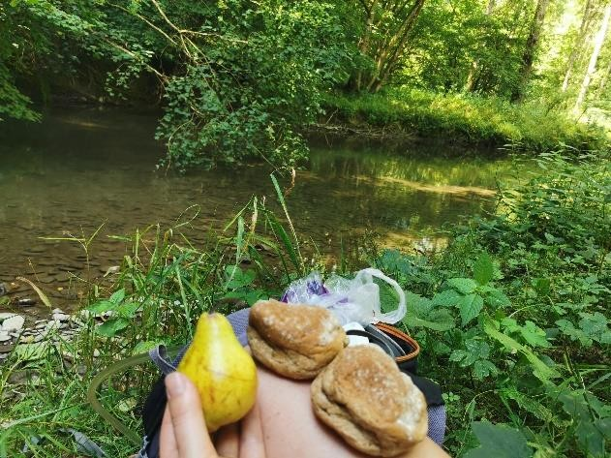
We spotted a kingfisher briefly on Hindwell Brook (not caught on camera).

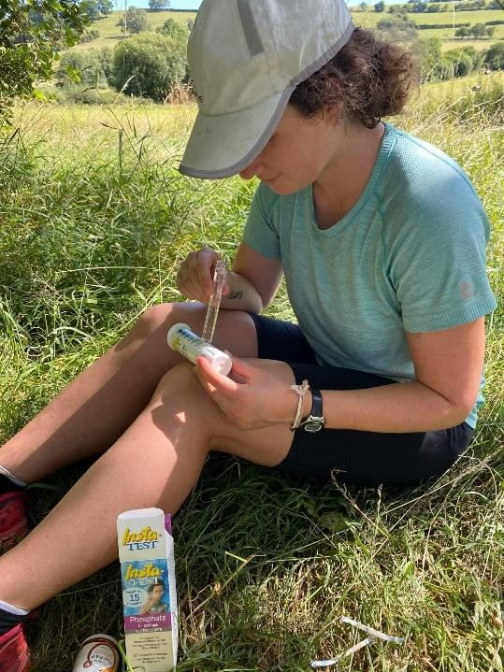
Water testing- after weeks without rain, levels were low.
CPRE’s team of citizen scientists take weekly tests across the catchment. This is helping map patterns and pollution: their data is now being used by the Environment Agency.

Thanks to George of the Riverside Inn Aymestrey, who showed us round their site at the end of the day. We saw both their work by the river and how they have increased the amount of food they grow themselves and use in their menu.

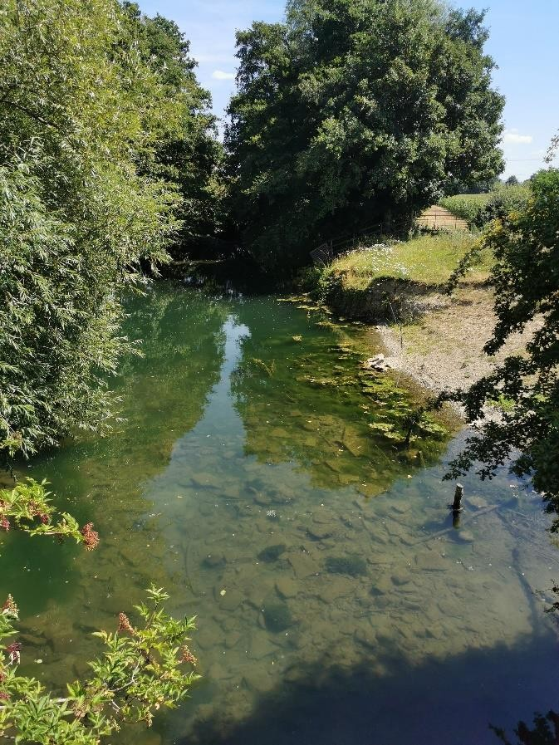
Tuesday 9/8: Day 3: Aymestrey to Leominster, on foot, 10ish miles.

Day 3 of my #Luggadventure was a day of two halves, with the transition marked by a much needed cold drink at the Kingsland tea rooms!
Part 1 was lovely, following the river through woods and farmland on well maintained public footpaths. Part 2 wasn't so great - a lot of road walking, and the paths that were supposed to exist didn't, resulting in trampling nettles, climbing precariously leaning fences and wading across the river (refreshing 🙂).
Then, on the outskirts of Leominster, #Lovelylugg became something else entirely - a modified, polluted-looking channel. At some point on this journey I had become quite invested in the health of the Lugg, so this really saddened me.

Not so lovely Lugg showing effects of runoff

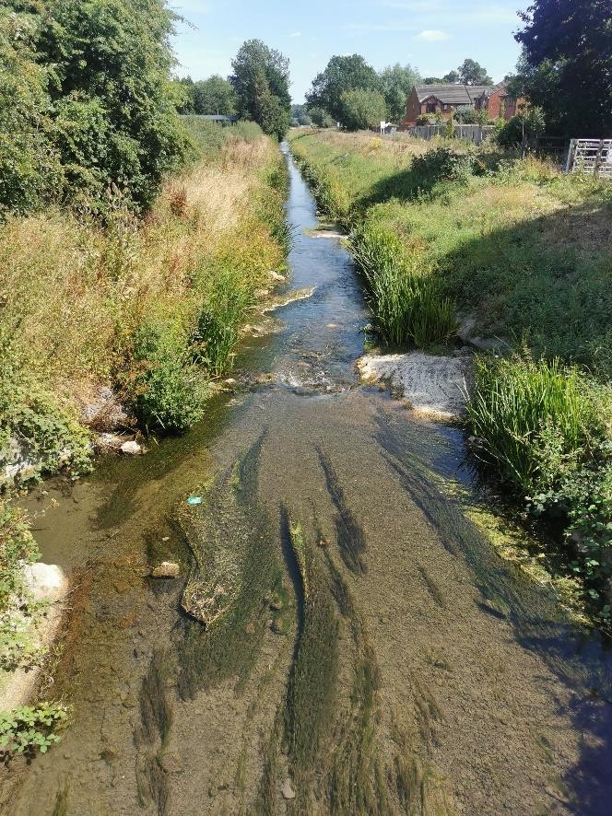
Although this stretch shows some problems you can see water crowfoot here – more than in the main river through Leominster.

Thanks to: -
- Jo Cockcroft who kindly provided the Lion Ballroom, Broad Street for an impromptu half way Mayoral social.
- Trish, Mayor of Leominster, Sophie and Bryony John, citizen scientist, who talked about the journey.
- Our musicians, who rounded off the event with river music and song: mayoral consort Andrew Morris, Kieran Morris and Louise Drewett

Weds 10/8: Day 4:
Leominster to Moreton on Lugg. 15ish miles by canoe, foot and bike.

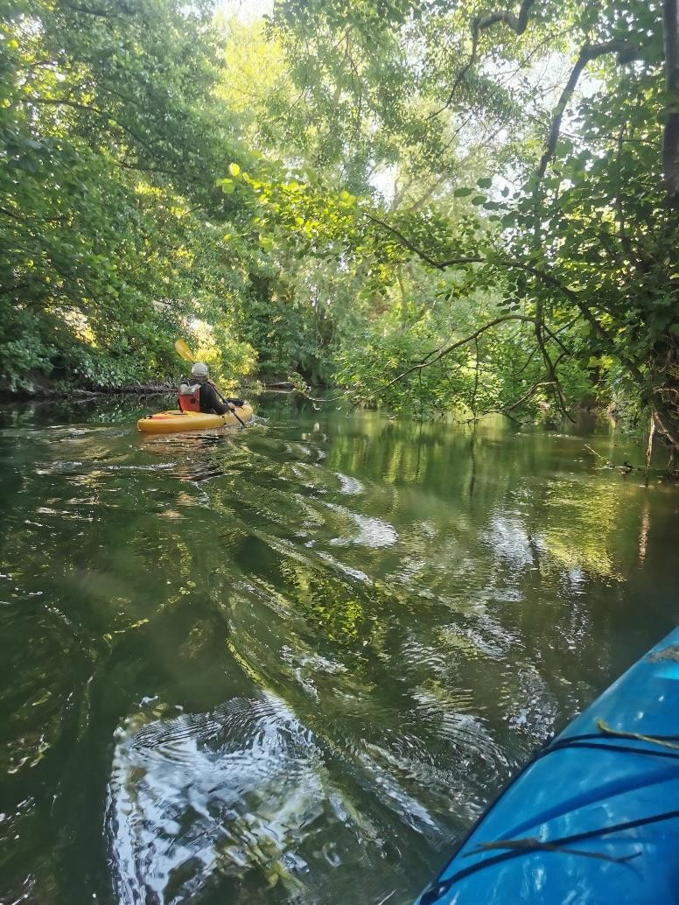
Day 4 of my #Luggadventure was truly adventurous! I set off by canoe with local Ian as my guide.

It started out as a nice paddle.

But soon became a battle of wills as we encountered blockage after blockage, caused by fallen trees, one requiring Ian's pruning saw!
These made a dam for rubbish, and the smell was disgusting and the water murky.

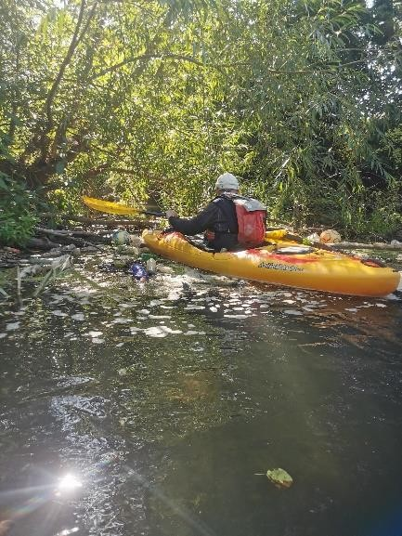
I would no longer swim in this river.
We abandoned ship early, and I hustled to make up for lost time, walking and biking the rest of the distance with few glimpses of the Lugg.
Public footpaths, including the Wyche Way from the top of Queenwood, provided a welcome respite from the main roads and the heat.

I enjoyed today from an adventurous sense, but the Lugg itself is no longer enjoyable. It's murky, polluted and smelly - a great shame. #SaveTheLugg

Thanks to:-
- Pete Blench, who kindly lent his canoe.
- Ian Brasnett of Hereford Canoe Club, who brought his considerable local knowledge, good humour and determination.
- Friends in Bodenham who loaned their period bicycle and provided route guidance when the canoe stage had to be cut short because of channel blockages.

Thurs 11/8: Day 5
Moreton on Lugg to the conference with the Wye, on foot, 10ish miles.

Day 5 was a straight forward 10 mile walk, mostly close to the Lugg on public footpaths. We started early at 7:30am to avoid the worst of the heat, and arrived at the confluence just after midday with a small group of supporters - adventure complete!!
Despite the challenges and despite the pollution, I have had a really enjoyable and interesting 5 days following the river and meeting many people who care about it. It will not be easy, but it's definitely a river worth saving! #Savethelugg #Luggadventure
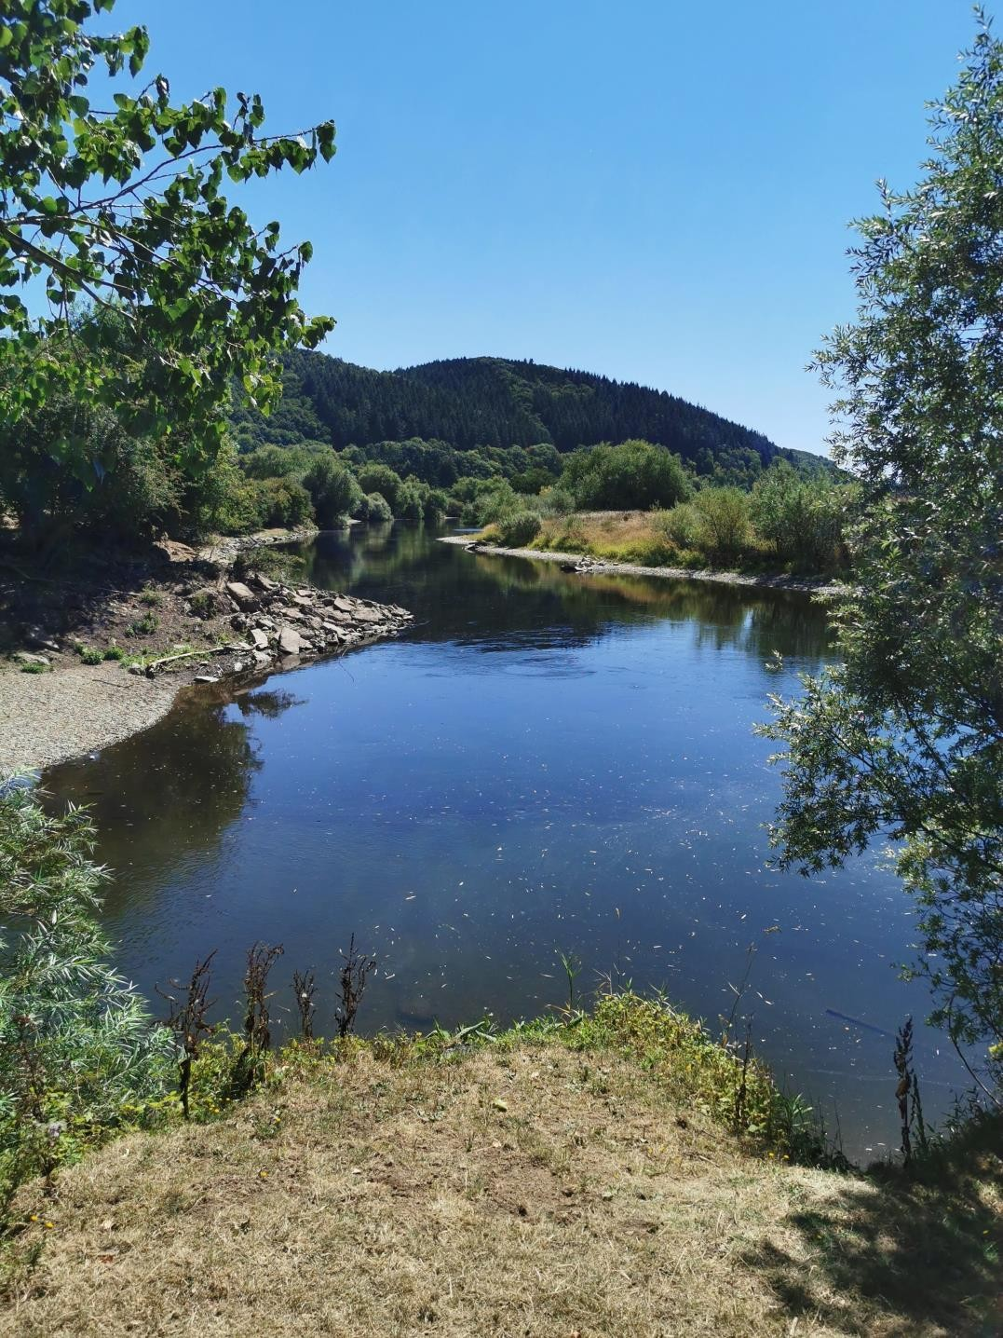
The confluence with the Wye- a very stately joining.

The trip raised awareness of the many challenges the River Lugg faces and raised funds for Trish’s Mayoral charity, CPREHerefordshire. Their work on the Lugg catchment focuses on citizen science and campaigning.
You can make a donation to their work at https://www.cpreherefordshire.org.uk/our-focus-in- herefordshire/

Thanks to :-

- Frances Weeks of Herefordshire Wildlife Trust, who told us about the management of the Lugg Meadows, recently cut for hay.
- The supporters who had helped along the way and several who joined Sophie at Mordiford for the final walk to the confluence.
- The vicar of Holy Rood church next to the Old Bridge, who offered the shade provided by the great yew in the churchyard as temperatures climbed to 30 degrees in the shade.
- Mark Jickells, who joined us: his film of his own source to confluence walk some years ago, with his brother, was an inspiration for undertaking this expedition.
- The Moon Inn for cool drinks and a sustaining lunch

